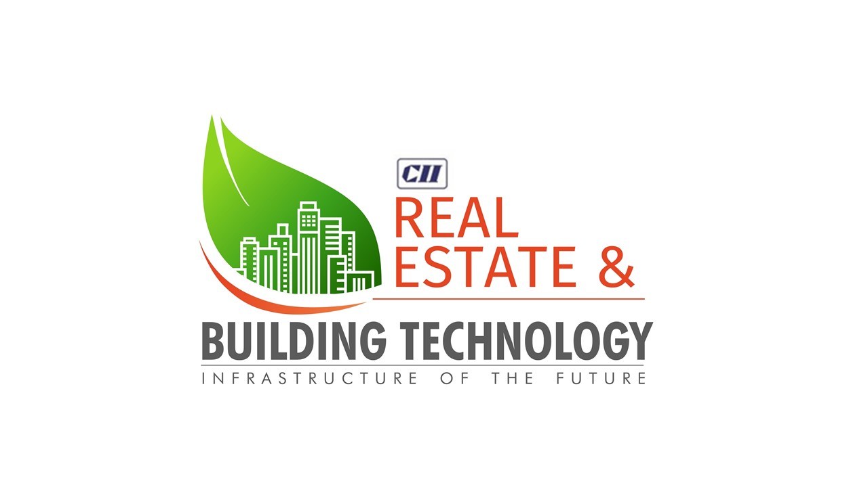

**POST SHOW REPORT**

***SUBMITTED BY:***

****

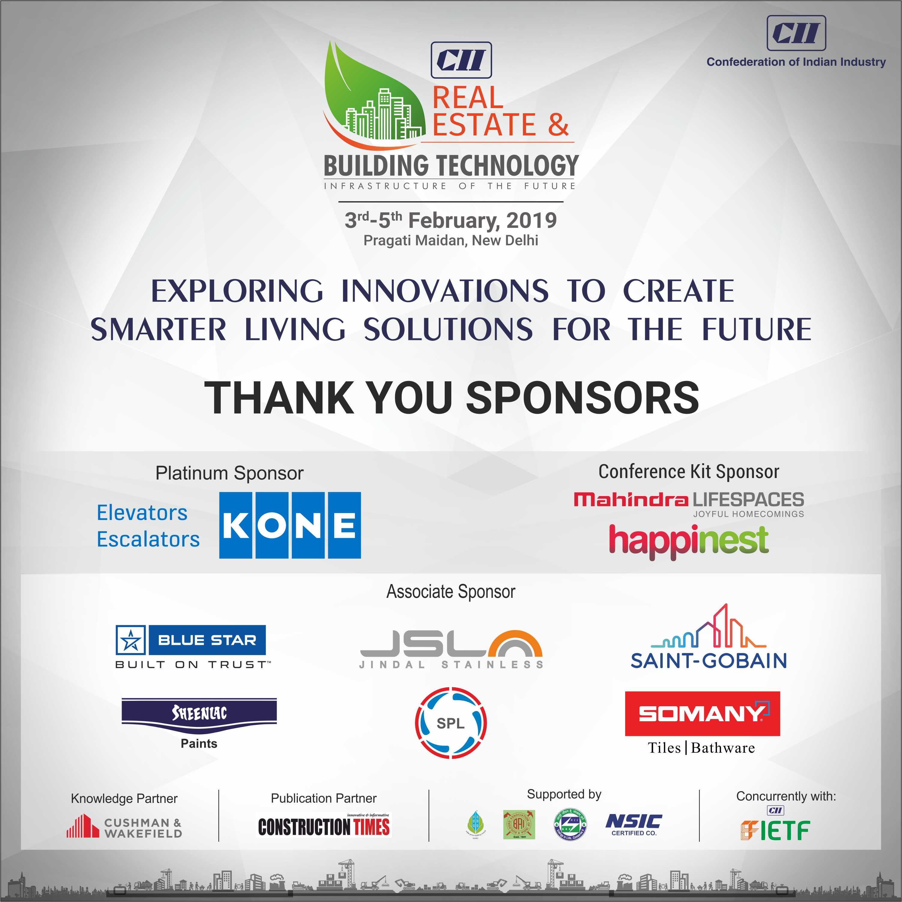

**INSIGHT OF REAL ESTATE SECTOR**

**­**

India’s real estate sector has witnessed to multiple paradigms which have brought about a transformative change to the sector. Largely driven by structural reforms enabled through landmark policies, we are in the midst of winds of change which are changing the very landscape of the real estate business and its practices. Short-term headwinds like demonetisation followed by implementation of RERA and GST have had a seminal effect on the way business is conducted with far-reaching ramifications of consolidation, fiscal prudence, corporate governance and accountability and disclosure norms in the sector which were hitherto unheard of.

Today, Indian construction and real estate industry has carved a niche of its own in developing and designing some of the finest buildings and projects, which are well acclaimed across the globe. This is a clear testimony of India’s thought leadership and expertise in real estate sector. Excellent policy impetus from the Government is further propelling the sector to scale greater and greener heights. This at the same time is offering significant growth opportunities to the stakeholders and in the process enabling them to forge vibrant partnership- both at the national and international level.

The last two years have also been very instructive in the way the sector is shaping up. Developers have taken conscious decisions of revamping their operations, adhering to regulations and aligning themselves to efficient business practices. A change is coming and is surely taking on wings. In this context, while we continue to see policy interventions being introduced, the implications for different stakeholders are varied in nature. As is usual in creating an effective policy, there is a process of evolution that usually ends up refining the rules to conform to the needs of all stakeholders.

Rapid urbanisation across the country has further triggered demand for more residential, commercial spaces and infrastructure projects. Focus on smart and green cities is offering the sector to design more ‘out of the box’ models, which are ecologically superior and economically viable. Adopting green building concepts and approaches is one of the hallmarks of Indian construction sector and this augurs well for facilitating a greener and healthier India.

India stands no: 2 in the world in terms of largest registered green building footprint, with over 5,000 projects adopting CII’s Indian Green Building Council (IGBC) rating systems. All these trends are indeed promising and augurs well for the spread and growth of the real estate sector. The growth potential of this sector is immense and is waiting to be tapped. With about 70 to 80 % of the India of 2030 is yet to be built, Indian construction sector is in for promising times. In days to come, we should design all the upcoming projects as green by design. Concerted efforts by all the stakeholders will further drive the momentum and pave way for new growth trajectories.

**EXHIBITION**

At this background, CII had organized the 2nd exhibition on “Real Estate & Building Technologies” from 3 – 5 February 2019 at Pragati Maidan, New Delhi The expo was comprise an elaborate exhibition with live demonstrations for visitors and mock up scale models intended to provide a unique look at the next generation of realty construction and design.

This Expo brings together leading real estate & building technology providers, consultants who were showcase their next generation, innovative and futuristic green technologies and strategies for the sector. The expo also offered a platform to share, learn and explore new growth opportunities in the sector.

Over the years, stakeholders have taken conscious decisions of revamping their operations and aligning themselves to efficient business practices and adopting green building concepts & technologies. These positive interventions and initiatives is equipping the sector set new global benchmarks and in the process enabling them tap new growth opportunities, he added.

Complemented the sector’s efforts is CII’s Real Estate & Building Technology Expo 2019. Around over 25,000 trade visitors attended the 3-day event and forging of new partnerships through 500+ structured B2B, B2G, G2G meetings.

***The 2nd edition of Real Estate & Building Technology Expo was marked by the following:***

* Conference on Housing & Building Technology on 4 February 2019
* Release of CII- Cushman & Wakefield report on ‘**Real Estate Development and Housing Technology’**
* BAM Award 2019 for stakeholders who made outstanding contribution to the spread and growth of the sector

**EXHIBITION SNAPSHOT**

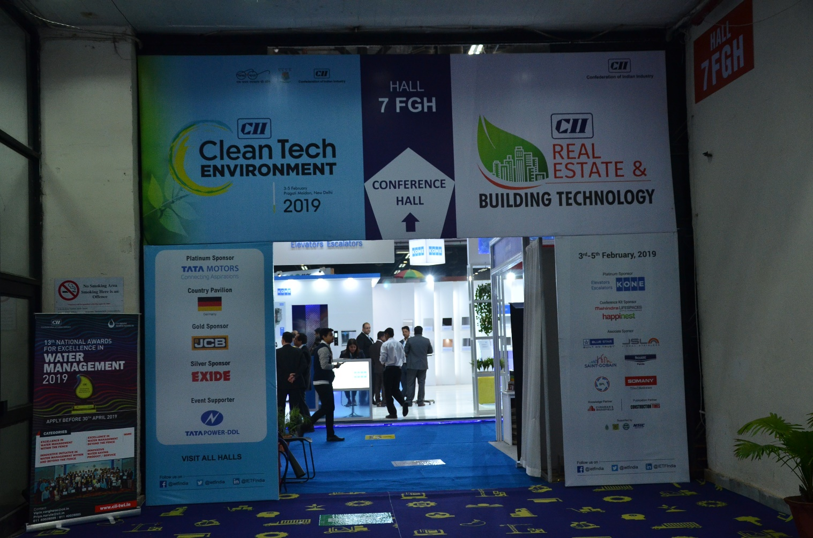

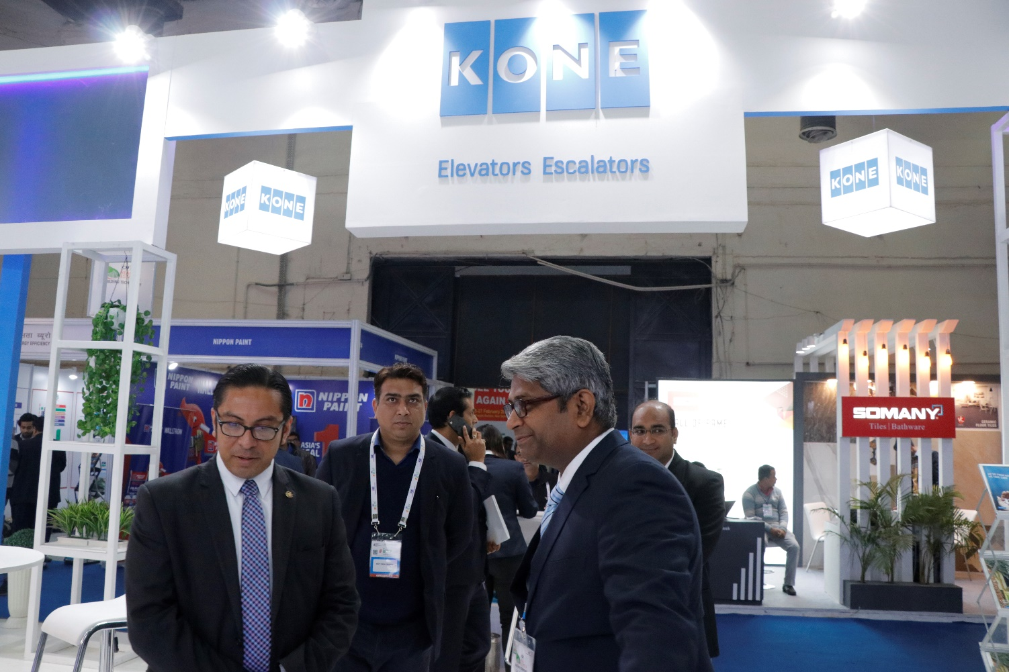

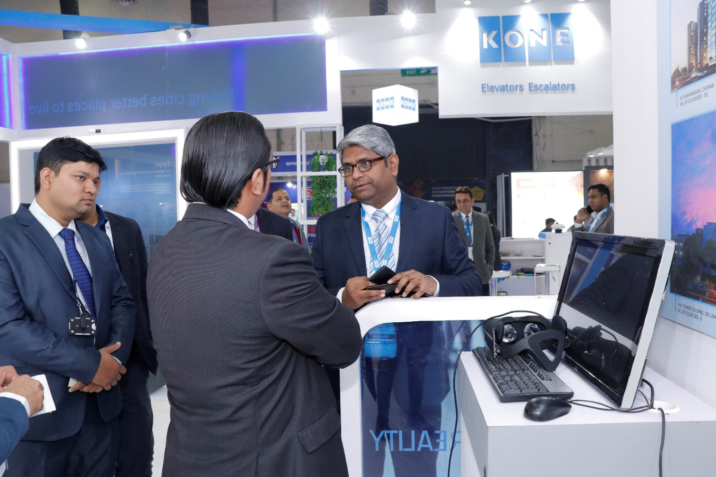

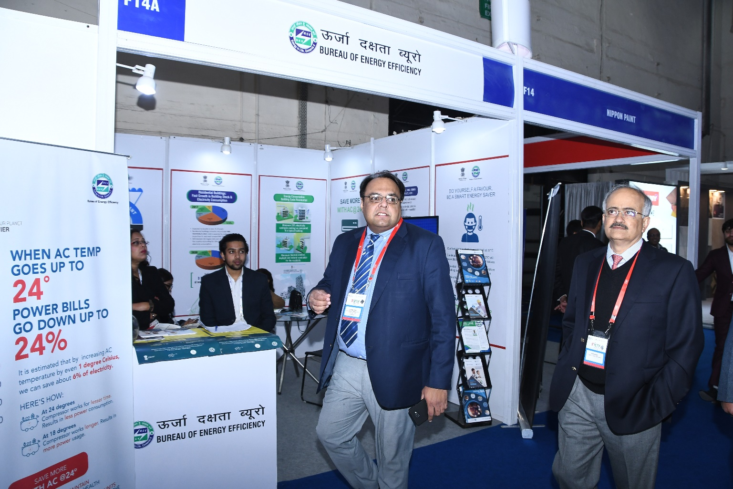

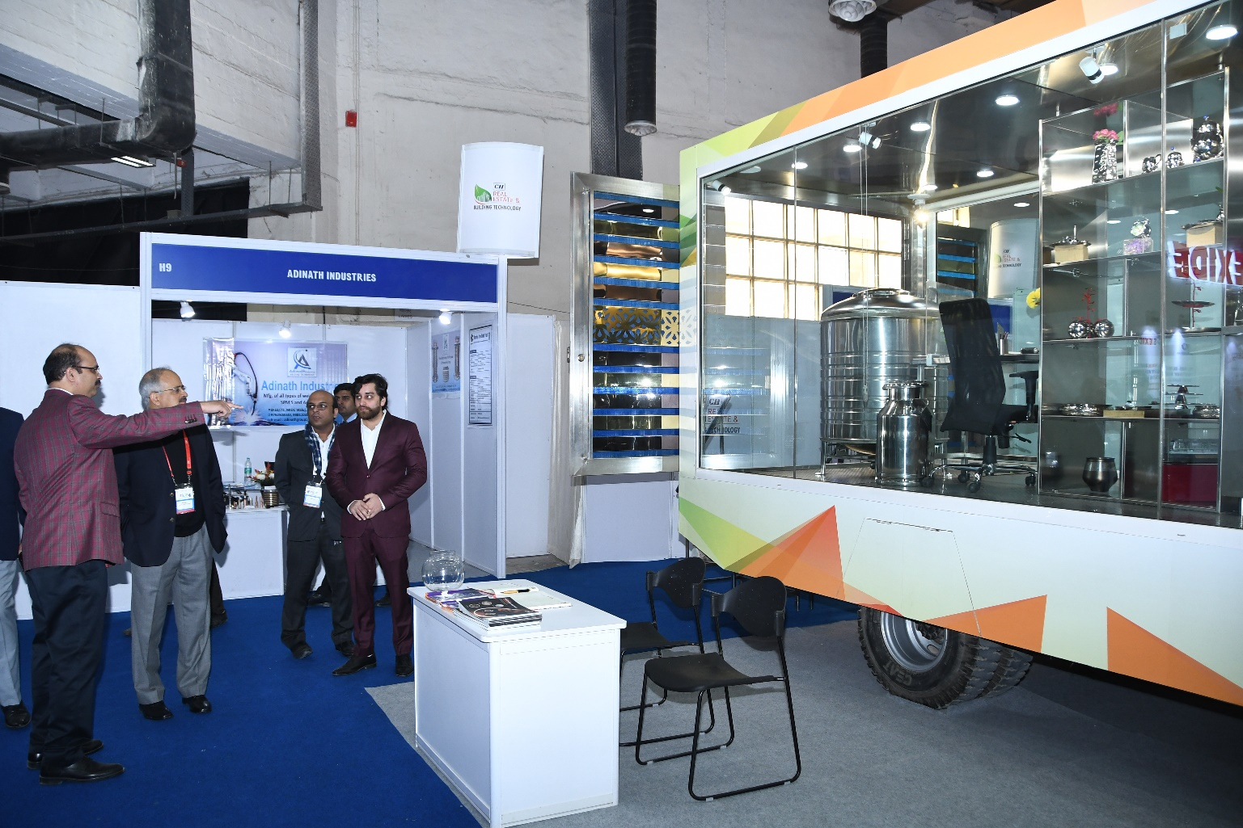

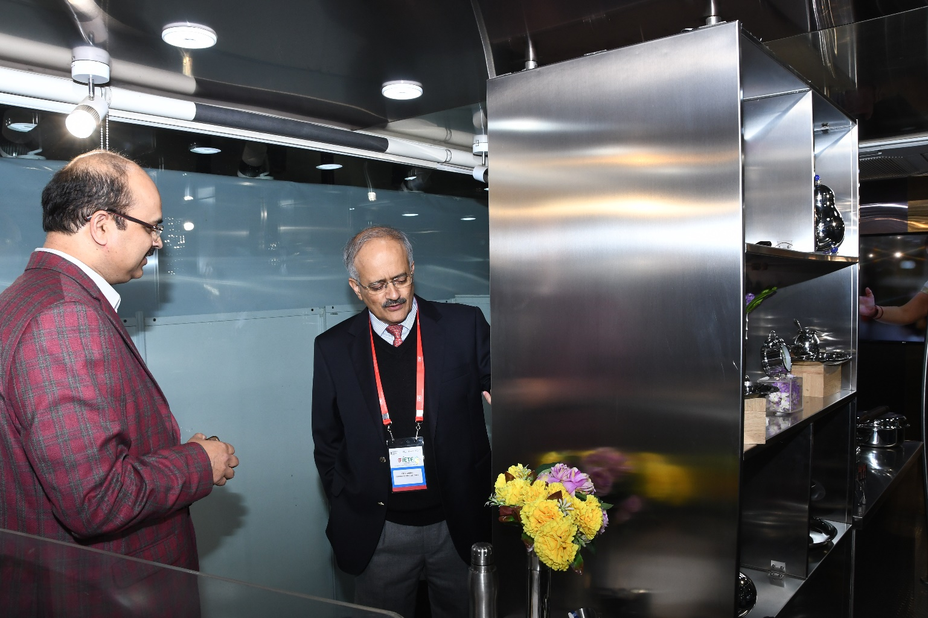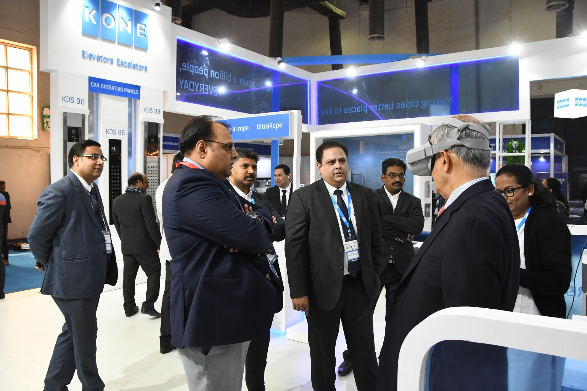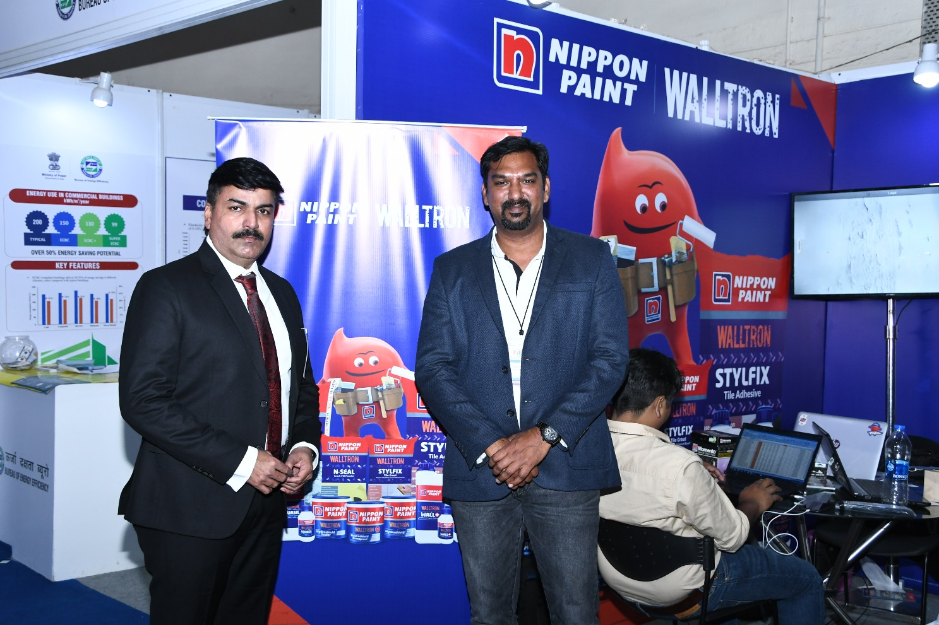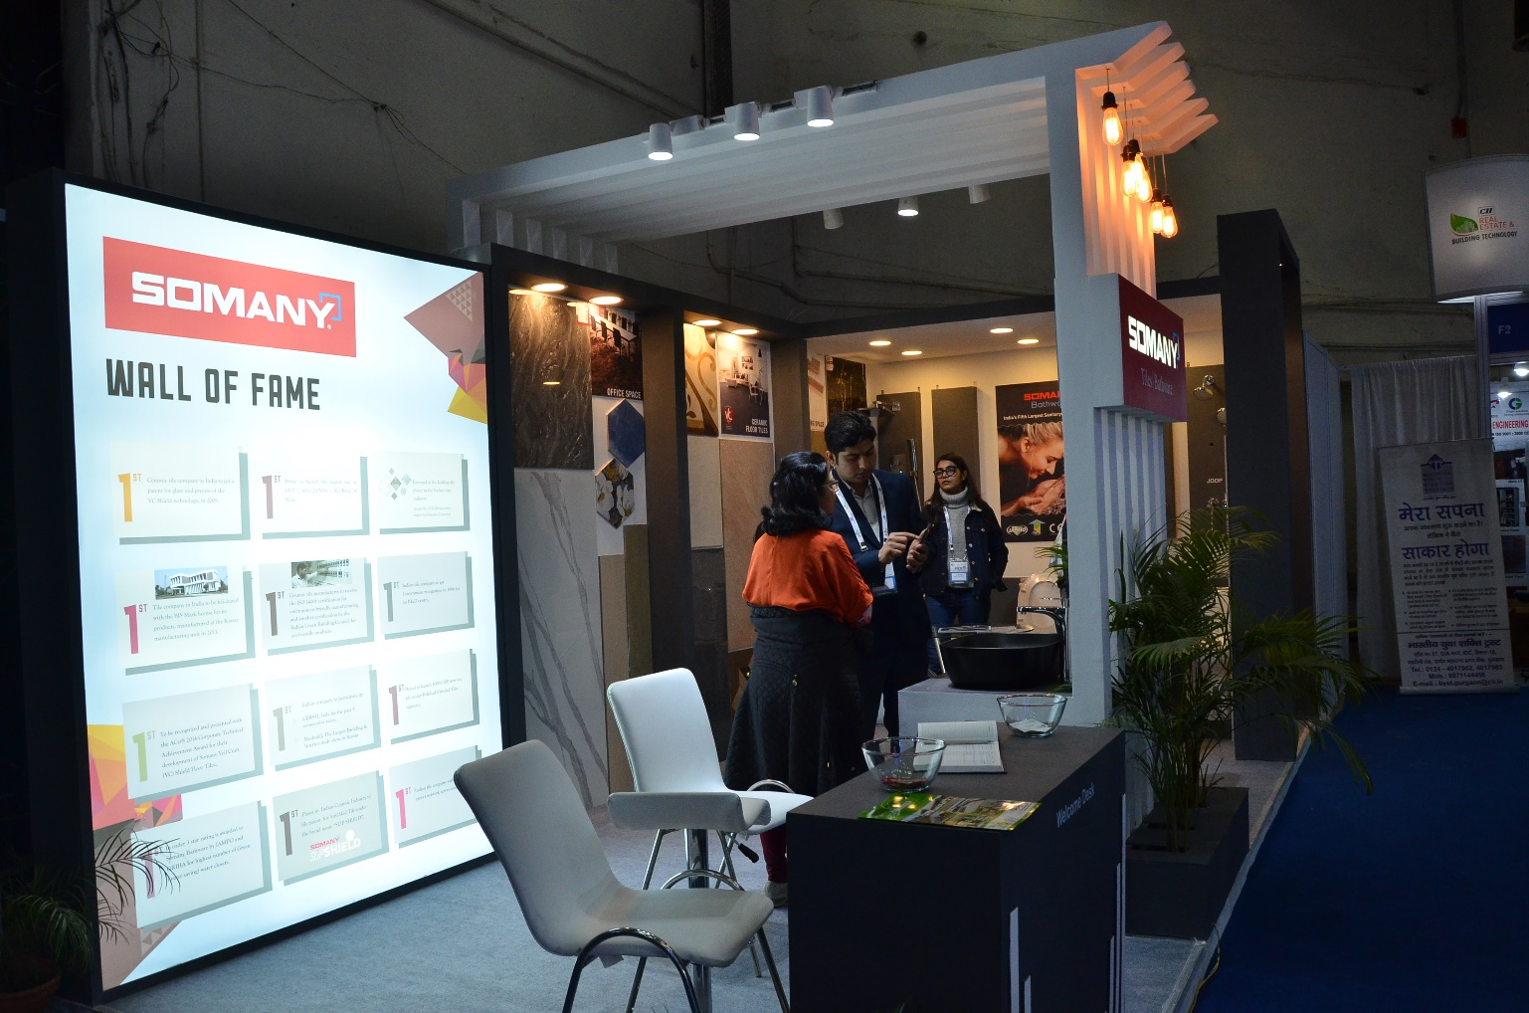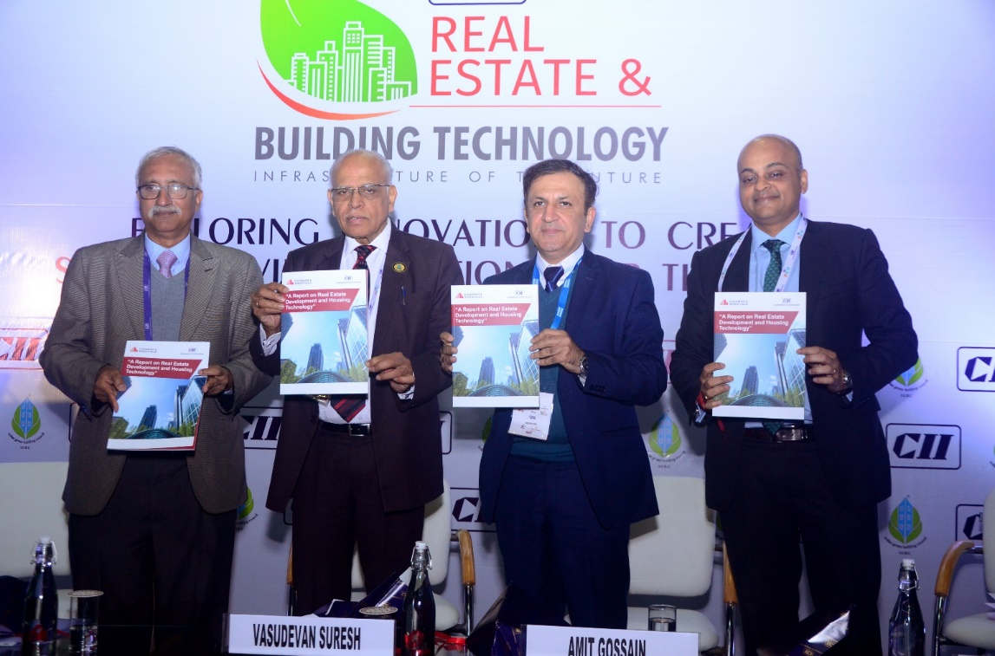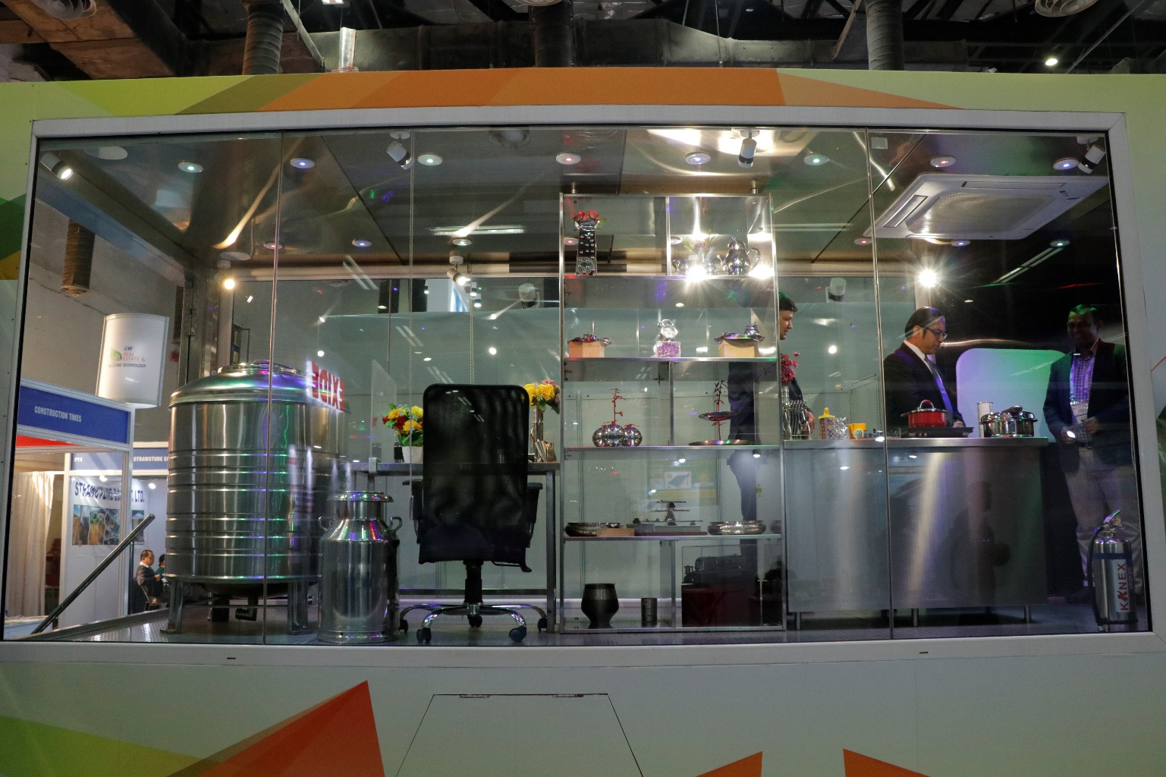

**CONFERENCE SNAPSHOT**

|  |
| --- |
| (L-R) Mr. S Raghupathy, Chief Operation Officer, CII, Mr. V Suresh, Chairman-IGBC, Mr. Amit Gossain, Managing Director, Kone Elevators India Pvt. Ltd. & Chairman – CII Real Estate & Building Technology Committee, Mr. Anshul Jain, Country Head & Managing Director, Cushman & Wakefield India releasing the report on Real Estate Development & Housing Technology during Seminar on Real Estate & Building Technology  C:\Users\suyash.mittal.CII\AppData\Local\Microsoft\Windows\INetCache\Content.Word\DSC_0242.jpg |
| C:\Users\suyash.mittal.CII\AppData\Local\Microsoft\Windows\INetCache\Content.Word\DSC_0207.jpg |
| C:\Users\suyash.mittal.CII\AppData\Local\Microsoft\Windows\INetCache\Content.Word\DSC_0181.jpg  C:\Users\suyash.mittal.CII\AppData\Local\Microsoft\Windows\INetCache\Content.Word\DSC_0179.jpg |
| C:\Users\suyash.mittal.CII\AppData\Local\Microsoft\Windows\INetCache\Content.Word\DSC_0308.jpg |